The SavvyInvestor Manual Test Plan – Week 1

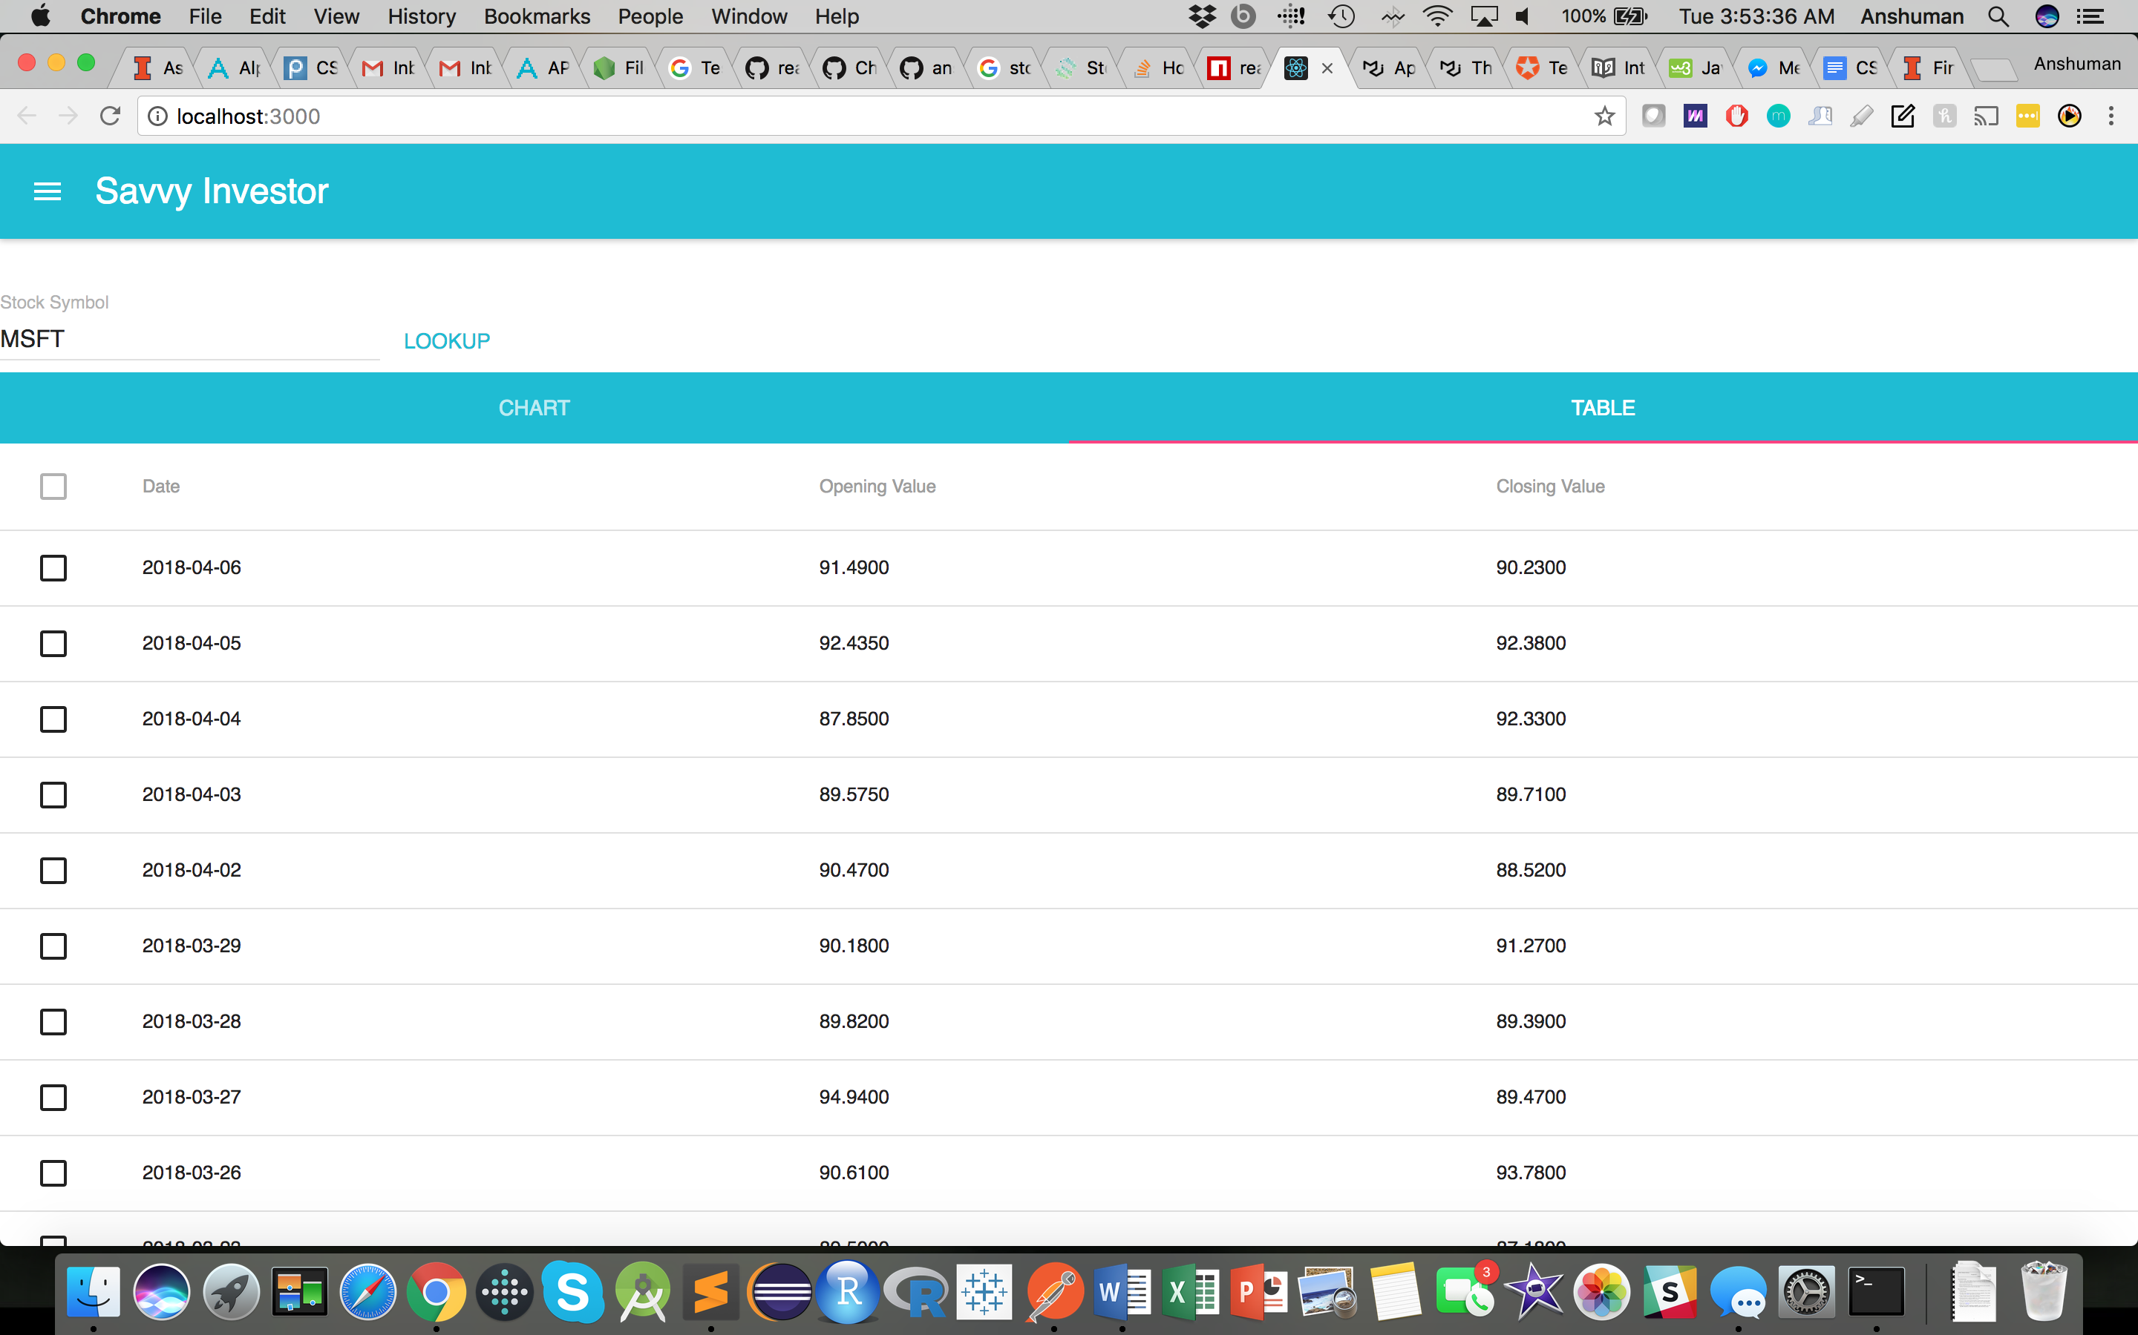After starting the Node server, the React server, and going to localhost:3000, the user should see the following screen.

The default company for the SavvyInvestor is Microsoft. The following components should be visible:

1. A TextInput field for the Stock Symbol
2. 2 tabs:
   1. Table
   2. Chart

The TextInput Field should be able to take text data, and should render error text if an invalid stock symbol is inputted into the field. If the symbol is valid, then the data should change to show the values of the new stock symbol.

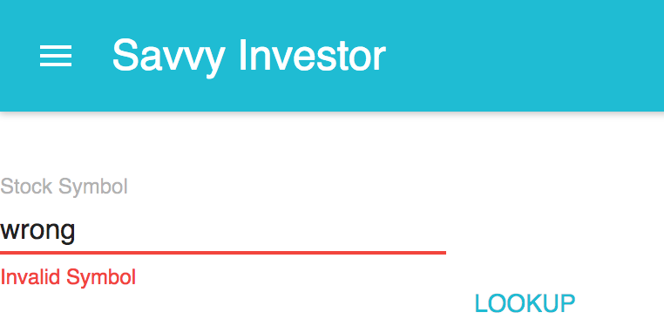



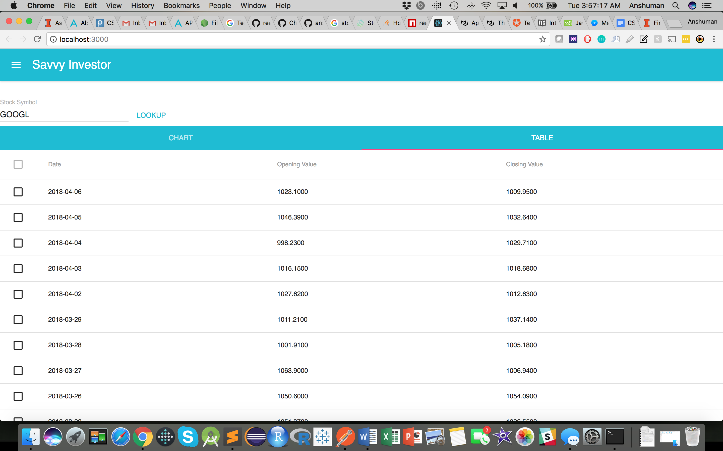

Upon clicking the Chart tab, the visual of the stocks opening and closing prices should render.

The visual is a multi-line LineChart. Upon changing the stock symbol in the top, the graph should readjust but otherwise behave similarly for incorrect symbols.

